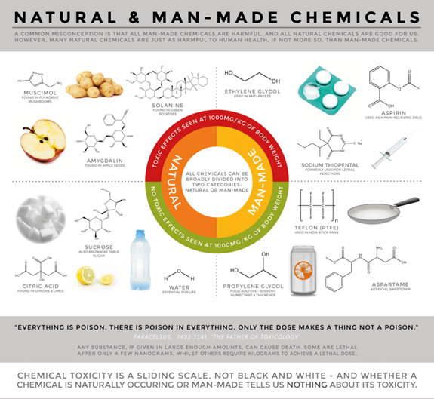

Intelligent Toxic/Poison Diagnosis and Treatment Recommendation System
  - Diagnose SYmptoms to poisonous substances and recommend Treatment based on knowledge base
Vimmi Taneja | Artificial Intelligence: CS5346 (Fall 2016) | 10/21/2016

Table of Contents
1. Introduction 3
1.1. Problem Statement 3
1.2. Solution 3
2. Contributions 3
2.1. Team members: Vimmi Taneja, Tseng Po-Teng, Lynn Thomas 3
2.1.1. Vimmi Taneja 3
2.1.2. Tseng Po-Teng 3
2.1.3. Lynn Thomas 3
Parts that we did together: 4
3. Analysis 4
3.1. DOMAIN 4
3.2. Problem with existing code 4
3.3. Proposal for the problem 4
4. Knowledge Base Design 4
4.1. Decision Tree 5
4.1.1. Backward Chaining Decision Tree 5
5. Inference Engine 7
5.1. Backward Chaining: 7
5.2. Forward chaining: 7
6. Program Implementation 7
7. Analysis of Program – Original Code vs. Student code 14
7.1 Readability 14
2. Maintainability 16
3. Reusability 17
Usability 21
Efficiency 21
8. Sample Run of Application 23
9. Conclusion 26
10. References 26
11. Appendix A 27
12. Appendix B 28
12.1. Rules for Backward Chaining: 28
12.2. Rules for Forward Chaining: 29
Project.cpp (Source Code) 30

Introduction

Problem Statement
Poisons are substances that cause disturbances in organisms, usually by chemical reaction or other activity on the molecular scale, when an organism absorbs a sufficient quantity. Understanding the symptoms of various poisonous and toxic substances on human body can be used to determine the cause and thus can be used to determine the nature of treatment necessary for the individual. The quickness and accuracy of such diagnosis is extremely important for the person affected.

Solution
To diagnose the symptoms of the patient and find out the poison behind those symptoms and recommend treatment for it is the goal of this project. The emergency room staff will feed the symptoms of the patient. Using Backward Chaining, our expert system will diagnose the toxic substance or the poison and then using Forward Chaining, it will recommend the treatment.

Contributions

Team members: Vimmi Taneja, Tseng Po-Teng, Lynn Thomas

Vimmi Taneja
- Did research on Poisons online
- Created backward chaining decision tree.
- Created rules for backward chaining.
- Debugged backward chaining cpp
- Debugged Forward chaining cpp
- Wrote code for parsing text file.
- Built structures and functions.

Tseng Po-Teng
- Did research on poisons
- Improved Forward chaining cpp
- Created Forward chaining decision tree
- Did backward chaining cpp.

Lynn Thomas
- Did research on animal poisons
- Did some part of backward chaining decision tree
- Created backward chaining rules
- Added code to backward chaining cpp
- Did some part in forward chaining tree

Parts that we did together:
- Backward chaining decision tree
- Forward chaining decision tree
- Backward chaining cpp.

Analysis

DOMAIN
This intelligent computer expert system is for an emergency room of a hospital to diagnose toxic substances and poisons and to recommend the treatment based on the diagnosis. Domain is emergency rooms in hospitals.

Problem with existing code
Existing code had issues such as readability and flexibility. Many of variable names were so short that they were not self-explanatory. Values were hardcoded which makes it difficult to maintain the code. Hardcoding increases the chances of errors and also reduces the flexibility. If we change value at one place and forget to change it at other place, then it will cause errors. Regarding readability, indentation was not correct.
Knowledge base (set of rules) were mixed with inference engine.

Proposal for the problem
Proposal was to name variables in self-explanatory way, remove old code and inefficient code such as goto statements and getchar(). We put size of lists in variable names instead of just a number, so that if we change list size, we change at one place and the new value will be used everywhere in the program. This ensures consistency, readability, and maintainability. We also proposed indentation to increase readability.
Set of rules to be separated from inference engine by putting them into text file so that modification of rules does not affect source code.

Knowledge Base Design
We researched various websites for poisons and their symptoms. We found a lot of poisons and we focused on animal poisons and some mentioned on CDC website.

Decision Tree
The decision tree for our project is split into two parts – one for forward chaining and one for backward chaining. The backward chaining decision tree starts with a conclusion of toxin/poison and traverses backwards.

Backward Chaining Decision Tree
Backward Chaining decision tree was constructed using several potential toxin or poisonous substances which a patient could be exposed to by virtue of inhalation, eye contact, skin contact or vasinity in the area which was affected. Following diagram is just a sub-set of a very detailed decision tree which can be found attached in Appendix A of this document following Conclusion and references.
Backward chaining starts with a goal and works backward. As an example, goal selected is “Poison”. Following is some part of decision tree which shows poisons with symptoms which start in less than 30 mins. Most of the poisons have nausea and vomiting as their symptoms so we start with them and then different symptoms lead to different poisons.
We have categorized poisons based on
- Animal poison
- Only eye exposure
- Time of onset of symptoms

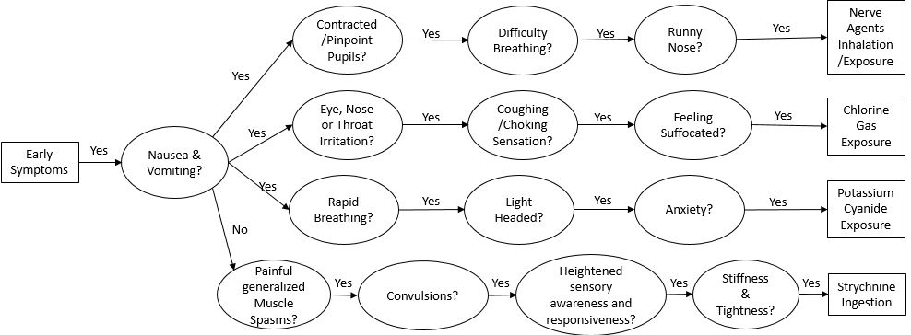
The tree for forward chaining starts with the poison name. Based on different poisons, the recommended treatment is different. There are 16 poisons in forward chaining which lead to 16 treatments. For example, view the top branch of the tree below. It starts with a node asking for poison name. For example’s sake, we will choose Arsenic. It leads to conclusion of treatment.

4.2 Rules
There are 2 sets of rules – One set for backward chaining and one set for forward chaining. Each set of rules is derived from its own corresponding decision tree. There are 27 rules for backward chaining and 16 rules for forward chaining.
See Appendix A for entire set of rules for forward chaining and backward chaining.

Inference Engine
Inference engines are the tools of Artificial Intelligence. Along with Knowledge Base they define the basic building blocks of an expert system. Inference engines apply logical rules to the knowledge base in order to deduce new knowledge.

Backward Chaining:
In our system, it is in BackwardChaining.cpp.
Data Structures: It has 4 lists – variable list, conclusion list, instantiated list and clause variable list. All 4 are arrays. For conclusion stack we have allocated 2 arrays – statement stack and clause stack. To keep track of the values in stack there is statement pointer. We start at top of stack and as we get more statements we keep decrementing statement pointer. As we pop rules out of stack, we increment stack pointer. At last, we check if all items are popped out then we finish processing and declare success.
The variable list, clause variable list and conclusion list are filled in manually and displayed at beginning of program.

Forward chaining:
Code is in ForwardChaining.cpp.
Data Structures: It has 3 lists – variable list, clause variable list, instantiated list. Each list is filled manually and displayed at the beginning of each run. These lists are used while processing conclusion queue. Conclusion queue is a list. There are 2 pointers – Front pointer for pointing to front of queue and back pointer to point to back of queue.

Program Implementation

6.2.1. Backward Chaining Algorithm Description
Backward chaining is a form of goal-driven reasoning (Artificial Intelligence 2010). It starts with a consequence and tries to find conditions (Antecedents) that cause the consequence in question. A recursive chaining is performed for all intermediate consequences that are reached during the process.
Our application uses this methodology to arrive at a poison based on information provided by a knowledge base and data entered by a user of the program.
Code snippets showing implementation of basic blocks
Output with User Interface, add snapshots of program executions with an example
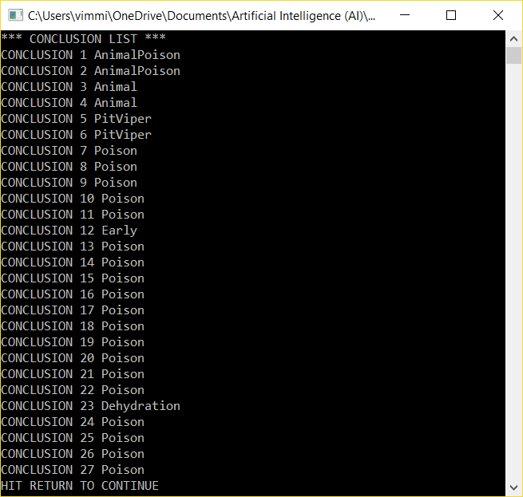

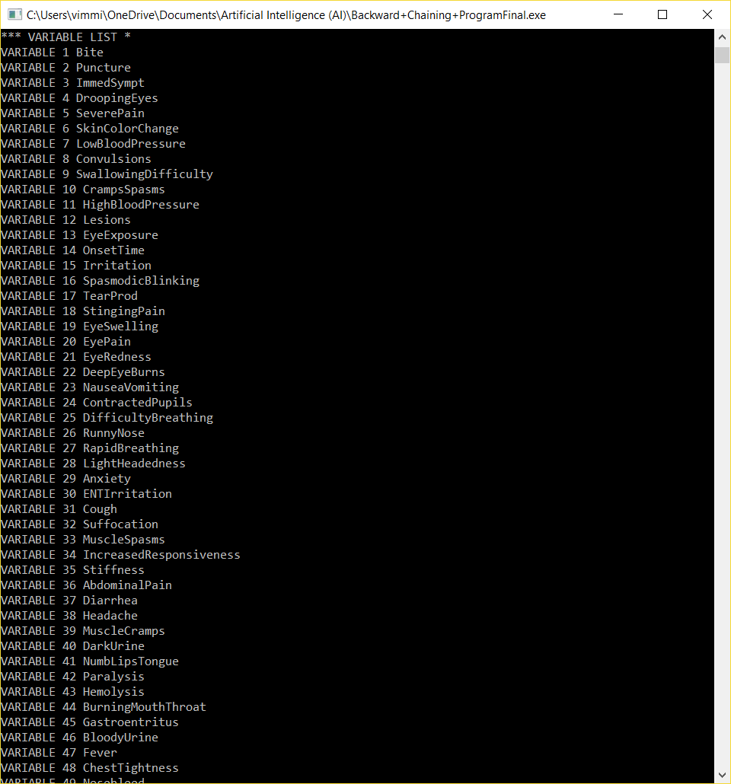
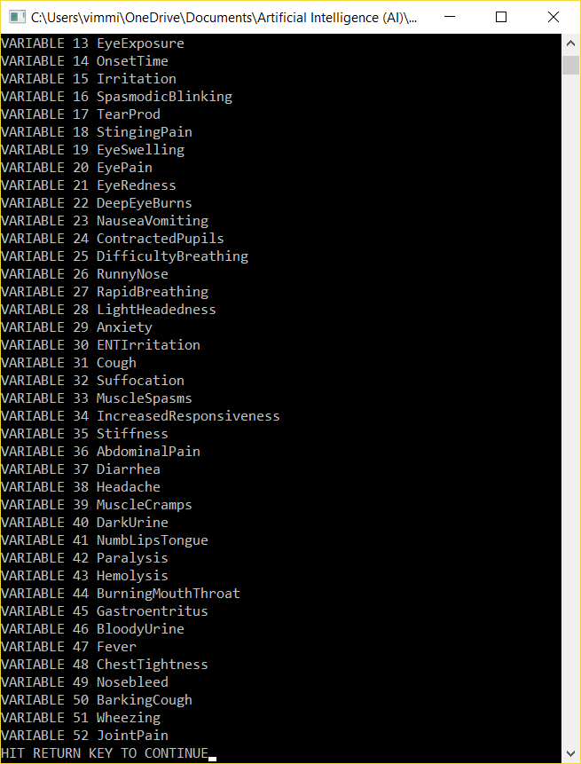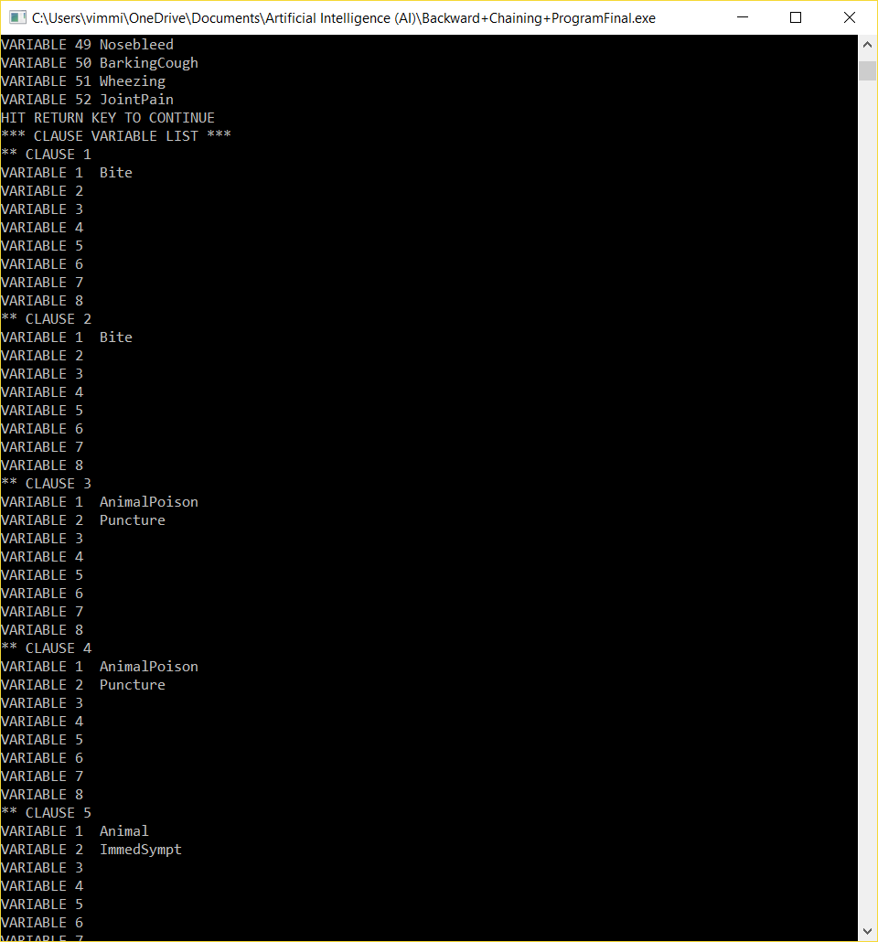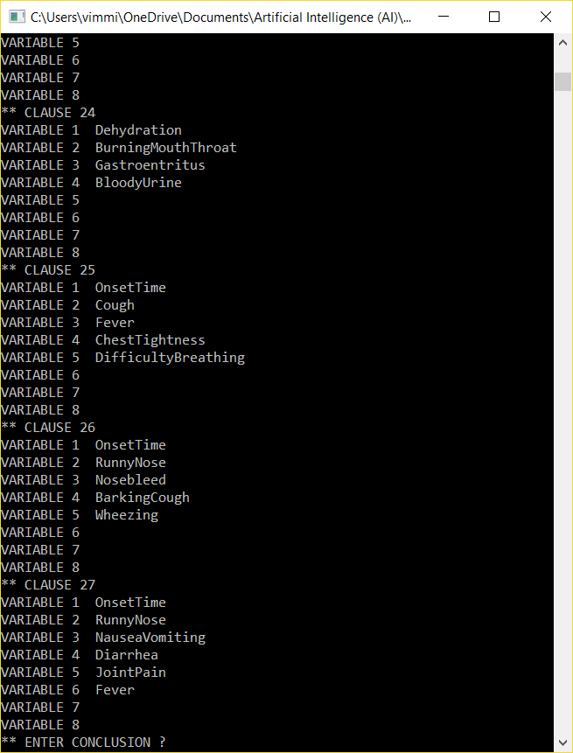

Similarly show FC related description, code snippets and output.
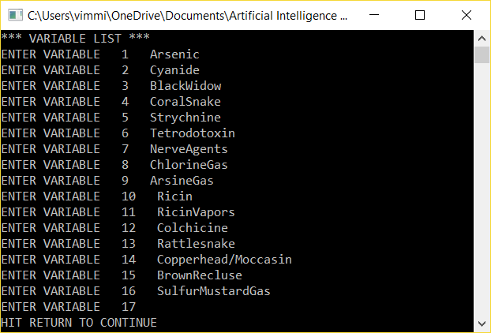
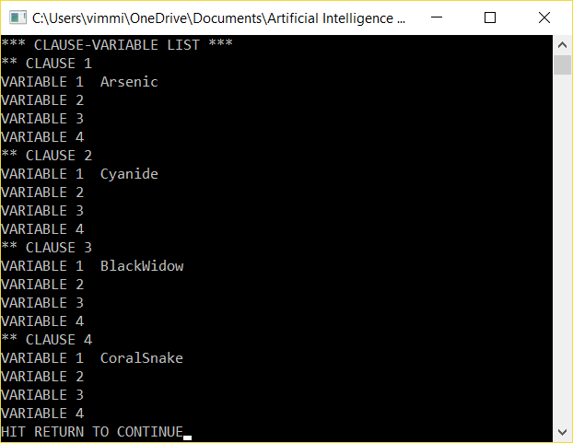

Analysis of Program – Original Code vs. Student code
The goal of this project was to improve upon the existing code provided. Based on the overall structure of the existing code, we decided to design our application using none of the code provided.
I will now go through some of standard software quality properties we used to compare/contrast the code.

7.1 Readability
We worked to provide very clear and concise code; this lends itself nicely to code maintenance and modification. To give an example of the contrasting approaches to development in terms of readability, a code segment is provided below.

Existing Code Snippet
/* conclusion list */
char conclt[10][3];
/* variable list */
char varlt[10][3];
/* clause vairable list */
char clvarlt[40][3];

Our Code:
Variable_f varlist[varlist_size]; // Variable list
Variable_f conclist[conclist_size]; // Conclusion list
Variable_f clausevarlist[clausevarlist_size]; // Clause variable list

- The size of lists is put into variables such as varlist_size instead of [10][3]. It tells reader immediately that it is variable list size.
.
- Existing code has only following functions other than main:
void determine_member_concl_list(void);
void push_on_stack(void);
void instantiate(void);

Rest of the things like initialization of lists, display of lists, inference engine, and rules were in main.

In our code we modularized and put main code into different functions which do particular work. This increases readability of code.

For example:
Void display_clauseList(Question* listQuestion, int size)
void display_conclusion_list(Conclusion* listConclusion, int sizeList)
void build_clause_list()
void build_variable_list()
void display_variable_list(Variable* variable_list, int sizeVariable)
int check_conclusion (string nameConclusion, Conclusion* listConclusion, int sizeConclusion) - checks if variable is in conclusion list or not. It is used while loading variable list.

Maintainability
Since previous code was hardcoded and we had around 25 rules, so hardcoding of so many rules, their if part, their then part and filling up of variable list, conclusion list, clause variable list was difficult with hardcoding. So we wrote the code from scratch.
Previous code had size of list hardcoded.

- Previous code: Hardcoding of list size.

char conclt[10][3]; // conclusion list
char varlt[10][3]; // variable list
char clvarlt[40][3]; // clause variable list
int instlt[11]; // initialization list

Current code: List size put into variables.
const int conclist_size = 30,
varlist_size = 14,
clausevarlist_size = 330

Variable_f varlist[varlist_size];
Variable_f conclist[conclist_size];
Variable_f clausevarlist[clausevarlist_size];

Effect of hardcoding: Due to above hardcoding of list size, everywhere else in code, whenever we needed to read the list or write in list, we had to remember and mention size of list. For example, in following cdoe, while initialization of list, we are specifying i < 11 .10 is size of list. This can lead to mistakes, non-flexibility, and difficult to maintain. If we want to change the list size, we will have to check whole code and change at many places. If we missed one place, it will lead to errors.

for (i=1; i<11; i++)
{
strcpy(conclt[i],"");
}

Current code:
for(int i = 0; i < conclist_size; i++)

Reusability
Knowledge base – set of rules was separated from inference engine. The original code used all hard-coded variables. This significantly decreases flexibility of the
application. New rules would affect source code and open the application to the possibility of error when making adjustments. In contrast, all rules in our code are within a text file. This eliminates the need for source code modifications when the rule set is modified. This fact alone increases the flexibility of our application and, in turn, has a positive impact on maintainability and reusability.

Existing code:
strcpy(conclt[1], "PO");
strcpy(conclt[2], "QU");
strcpy(conclt[3], "PO");
strcpy(conclt[4], "PO");

Our code:
Rules were written in separate text file. They were written in following format:
386 -- Number of lines in the text file.
Bite -- Clause variable
No -- Clause variable value
then
AnimalPoison -- conclusion
No -- conclusion value
Bite
Yes
then
AnimalPoison
Yes

Above set of lines correspond to 2 rules –
- If Bite = No then Animal Poison = No
- If Bite = Yes then Animal Poison = Yes

Rules are parsed by the code and variables and conclusions were put into their corresponding lists.
Our code:
if (bufferInput == "then") //then part
{
file >> listConclusion[countStatement].name; //answer
file>>listConclusion[countStatement].possibleAnswer; //answer value
countLine++; //as it reads one more line for "then"
countStatement++;
countClause = 0; // then part being processed, so clause count set to 0
}
Else //if part
{
listQuestion[countStatement * clause_per_statement + countClause].name1 = bufferInput; // Getting name of if clause
file >> listQuestion[countStatement * clause_per_statement + countClause].value1; // Getting value of if clause
countClause++; // Increment clause count
}
countLine+=2; // already read 2 lines for name and value each

Loading of lists
Existing code – Loading of conclusion list was manual.

Existing Code Snippet:
strcpy(conclt[1], "PO");
strcpy(conclt[2], "QU");
strcpy(conclt[3], "PO");

Our Code: Conclusion is read from file and filled into list.
Our Code:
if (bufferInput == "then") //then part
{
file >> listConclusion[countStatement].name; //answer
file >> listConclusion[countStatement].possibleAnswer; //answer value

Loading of variable list was manual. Developer had to specify variable names and location in variable list.

Existing Code:
strcpy(varlt[1], "DE");
strcpy(varlt[2], "DI");
strcpy(varlt[3], "EX");

In our code variable list is filled from clause variable list
Our Code:
int build_variable_list(Variable* listVariable, Question* listClause, int sizeClause, Conclusion* listConclusion, int sizeConclusion)
{
int sizeVariableReal = 0;
for (int i = 0; i < sizeClause; i++) //go through clause list
{
if (listClause[i].name1 != "") //if it's not a empty clause
{
//don't put it if it's a conclusion
if ( check_conclusion(listClause[i].name1, listConclusion, sizeConclusion) == -1 )
{
for (int j = 0; j < sizeClause; j++)
{
//only put every variable once
if (listVariable[j].name == listClause[i].name1)
{
break;
}
else if (listVariable[j].name == "")
{
listVariable[j].name = listClause[i].name1;
sizeVariableReal = j + 1;
break;
}
}
}
}
}
return sizeVariableReal;
}

Loading of clause variable list was manual. Location of clause in clause variable list depends upon number of clauses. In the previous code, number of clauses was hardcoded to be 4.
(statsk[sp] -1) *4 + clausk[sp];

That’s why, location in list are 1, 5, 9. This is difficult to change if we change number of clauses.
strcpy(clvarlt[1], "DE");
strcpy(clvarlt[5], "DE");
strcpy(clvarlt[9], "DE");
strcpy(clvarlt[10], "DI");

Current code:
Following structures were used:
struct Variable
{
string name;
string value;
bool instantiate;
};

struct Conclusion
{
string name;
string value;
string possibleAnswer;
};

struct Question
{
string name1;
string value1;
};

Our code: It is easy to build clause variable list even if we change the size of clauses per rule. Number of clauses is stored in variable, location is calculated by formula.
const int clause_per_statement = 10;
int countStatement = 0; // Rule number
int countClause = 0; // Clause count in one rule

listQuestion[countStatement * clause_per_statement + countClause].name1 = bufferInput;
file >> listQuestion[countStatement * clause_per_statement + countClause].value1;
countClause++;

Usability
The user interface of the original code uses unclear phrases when prompting the user for
information.

Existing code:
case 1: printf("INPUT YES OR NOW FOR DE-? ");
gets(de);
break;
case 2: printf("INPUT YES OR NO FOR DI-? ");

Our code:
cout << "\nDoes the patient have \"" << listVariable[i].name << "\"? (Yes/No)" << endl;

Output on screen
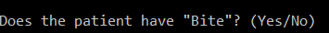
Our code has more descriptive output, easy to understand by user. It also asks the user if wants to do another search. In previous code, session terminated after one search.
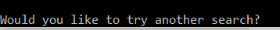

Efficiency
In terms of time and space complexity, space complexity is more in our code. We have more rules as compared to given code. Our lists – variable list, conclusion list, clause variable list are long as we have 27 rules, 330 allocations in clause variable list (10 locations per rule). We load all of the lists at runtime so they are in memory while program is running. In contrast, less memory is used by original code as it has less rules and they are in source code. We tried to improve efficiency by removing old code such as gets() and inefficient code such as goto statements. Gets() is depleted. It has been replaced by cin.

Existing code:
printf("HIT RETURN TO CONTINUE");
gets(buff);

Our code:
cout << "HIT RETURN KEY TO CONTINUE";
cin.get();

Existing code: Goto statements were used to jump to different location in code.
/* it is a conclusion push it */
goto b520;

clausk[sp] = clausk[sp]+1;
goto b545;

Our code: We replaced 2 goto statements with recursion.
string get_conclusion(string conclusion, Conclusion* listConclusion, Question* listClause, Variable* listVariable, int sizeConclusion, int clausePerStatement, int sizeVariable)
{
int indexConclusion = -1;
int indexVariable = -1;
bool stopPath = false;
//if the answer from the user is already against the current rule, stop it.

cout << "Trying to get conclusion: " << conclusion << endl;

//search conclusion to find which clause has it
//num_statement is the size of conclusion list
for (int i = 0; i < sizeConclusion; i++)
{
if (conclusion == listConclusion[i].name)
{
indexConclusion = i;
cout << "Checking conclusion#" << indexConclusion<<endl;

if (indexConclusion == -1)
{
return "No Match";
}

else //examine this one conclusion and see if we can get the possible answer
{
//Find clause which can generate the variable/conclusion the last clause need
for (int i = indexConclusion * clausePerStatement; i < (indexConclusion + 1) * clausePerStatement; i++)
{
if ( listClause[i].name1 != "" )
{
//check if variables are initiated or any of them is conclusion
int indexSubConclusion = 0;
indexSubConclusion = check_conclusion(listClause[i].name1, listConclusion, sizeConclusion);
if (indexSubConclusion != -1) //it's a conclusion
{
listConclusion[indexSubConclusion].value = get_conclusion(listClause[i].name1,
listConclusion, listClause, listVariable, sizeConclusion, clausePerStatement, sizeVariable);

We traverse through the conclusion list to find a match for the conclusion entered by user. If match is found, then we check clause variable list. If the clause is a conclusion, then we call the above function again recursively to get to that rule.

Sample Run of Application
Taking an example of “Chlorine Gas”, in the following snapshots, we will see how the backward chaining is able to reach a conclusion correctly and then feeding that output into forward chaining leads to determining the treatment recommendation for the poisonous substance.

When we kickoff the program, it displays Conclusion List, Variable List and then followed by Clause Variable List. After that the program prompts user to input the Conclusion. In our example, we enter, “Poison”.

Then the program based on the Knowledge Base, starts inquiring about various symptoms. Based on user’s answers, it steers the queries based on backward chaining principles. If you see the output snapshot below, first we answer the program resolves that it is not animal poison since rule #16 in our case was not resolved. Then the programs traverses other nodes of the decision tree to figure out which kind of poisonous substance has the patient been exposed to. Depending on the answers, and its traversal of Decision Tree, the program successfully determines that these symptoms are because of “Chlorine Gas” as shown in the snapshot below.
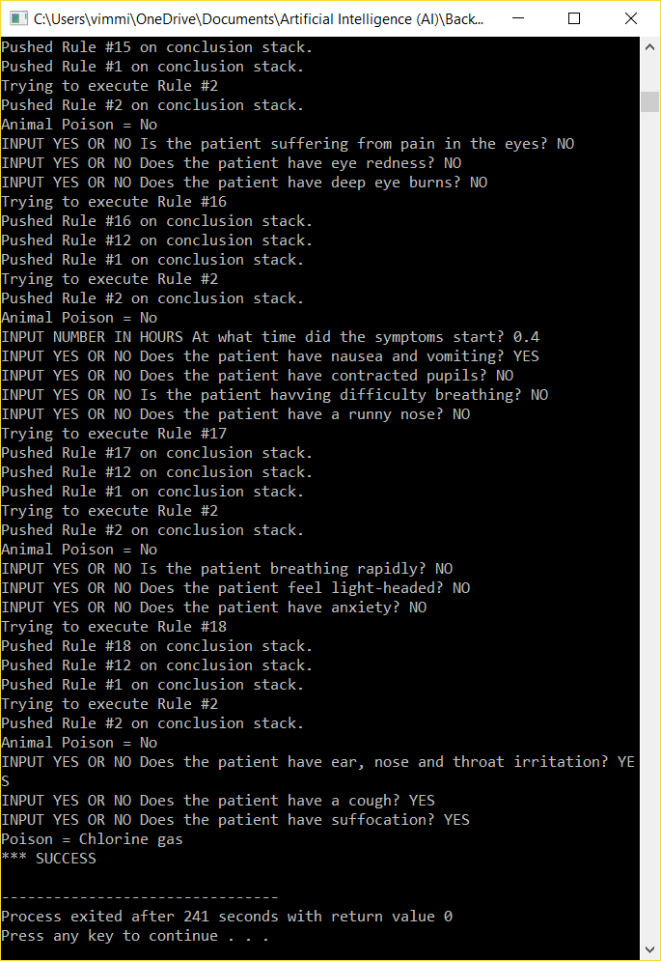
After the successful conclusion of this being a case of “Chlorine Gas” exposure, the user can then easily go to Forward Chaining program where out of the available Variable List, it can easily determine the recommended treatments for this Poisonous substance.

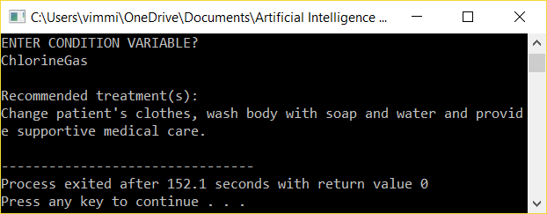

Conclusion
Working on this project provided a very good opportunity to understand the Forward and Backward Chaining algorithms in practical applications. In addition to this, I was able to get a very good understanding of various common toxins and poisons around whose source could be animal or chemicals used in daily life as well. Although there are much more toxins and poisons in the world than the ones which we mentioned within our project scope, I feel the knowledge base we provided serves as a good start. Based on the flexibility inherent in our project design, more intelligence can be built into our Expert System quite easily for increased complexity by providing more poisonous substances and the applicable treatments for them.

References
Russell, Stuart, and Norvig, Peter. Artificial Intelligence, A Modern Approach. 3rd ed.
Upper Saddle River, New Jersey, 2010
Centers for Disease Control and Prevention
https://www.cdc.gov/
American Association of Poison Control Centers
http://www.aapcc.org/
National Capital Poison Center
http://www.poison.org/
Wikipedia.(2012). Backward Chaining. Retrieved from Wikipedia:
http://en.wikipedia.org/wiki/Backward_chaining
Wikipedia.(2012). Forward Chaining. Retrieved from Wikipedia:
http://en.wikipedia.org/wiki/Forward_chaining

Appendix A
  - Project Description
Create an intelligent computer expert system for an emergency room of a hospital to diagnose toxic substances and poisons and to recommend the treatment based on the diagnosis. Perform research using Web or any other source to collect knowledge about the symptoms caused by toxic substance and poisons as well as their treatments. The emergency room staff will feed the symptoms of the patient. Using Backward Chaining, your expert system will diagnose the toxic substance or the poison and then using Forward Chaining, it will recommend the treatment. After collecting knowledge, develop a decision tree for Backward Chaining and a decision tree for the Forward Chaining. Then transform the decision trees into rules. The decision trees should be big enough to generate a minimum of thirty rules in total (more rules are fine). The rules should contain variables. Implement the expert system program, employing Backward Chaining and Forward Chaining methodologies.
Develop a user-friendly interface, which receives input data from an emergency room staff in restricted English format, uses keyword matching, and responds in a restricted English format.
The inference engine programs are provided to you on TRACS but they are intentionally made inefficient and erroneous. Instead of blindly using the inference engine programs, you must study them and modify them to make them as good as possible. In fact, you may want to rewrite them. But you must use the methodologies taught in the class and used in these programs. Use C++ language. Your ‘main’ function will call the two other functions, i.e., ‘Identify Poison’ and ‘Treatment’.
Form a team of a maximum of three students. You are expected to develop the decision trees, rules, interface, and the inference engines as a team. After programs are developed, each member of the team will follow the following six steps individually:
1. Run the program with the rules for a minimum of three goals (three Poisons). Each run will be initiated by a user through the Interface. The program will identify the type of the poison and provide a list of treatments for that poison.
2. Print intermediate results of at least one run to trace your program.
3. Analyze the results, and the efficiency of the program.
4. Write his/her REPORT explaining the problem, domain, decision trees, rules, methodologies, programs, modifications to programs, the analysis of programs and the analysis of results.
5. Clearly identify the contribution of each team member.
6. Demonstrate the execution and performance of the program.

Appendix B

Rules for Backward Chaining:
- If Bite = No then AnimalPoison = No
- If Bite = Yes then AnimalPoison = Yes
- If Bite = yes, and Puncture = yes, Then Animal = Snake
- If AnimalPoison = yes, and Puncture = no, Then Animal = Spider
- If AnimalPoison = YES and Animal = Spider, and ImmedSympt = yes, Then PitViper = yes
- If Animal = Snake, and ImmedSympt = no, Then PitViper = no
- If PitViper = yes, and DroopingEyes = yes, and SeverePain =yes, Then Poison = Rattlesnake
- If SpiderBite = yes, and CrampsSpasms = yes, and HighBloodPressure = yes, Then Poison = Black Widow
- If SpiderBite = yes, and CrampsSpasms = no, and Lesions = yes, Then Poison = Brown Recluse
- If AnimalPoison = No and OnlyEyeExp = No then Early = Yes
- If AnimalPoison = No and OnlyEyeExp = Yes and IrritationEyes = Yes and SpasmodicBlinking = Yes and TearProd = Yes and StingingPain = No then Poison = Cyanogen Chloride.
- If AnimalPoison = No and OnlyEyeExp = Yes and IrritationEyes = Yes and SpasmodicBlinking = Yes and TearProd = Yes and StingingPain = Yes and Swelling = Yes then Lewisite.
- If AnimalPoison = No and OnlyEyeExp = Yes and IrritationEyes = No and EyePain = Yes and Redness = Yes and Burns = yes then Poison = Sodium Cyanide
- If Early = yes and NauseaVomiting = Yes and ContractedPupils = Yes and DifficultyBreathing = yes and RunnyNose = yes then Poison = Moderate exposure to NerveAgents.
- If Early = yes and NauseaVomiting = Yes and RapidBreathing = Yes and LightHeadedness = Yes and Anxiety = Yes then Poison = Potassium Cyanide
- If Early = Yes and NauseaVomiting = No and MuscleSpasms = yes and Convulsions = yes and IncreasedResponsiveness = yes and Stiffness = yes then Poison = Strychnine
- If Early = yes and NauseaVomiting = Yes and ENTIrritation = Yes and Cough = Yes and Suffocation = Yes Then Poison = Chlorine gas
- If AnimalPoison = No and Time > 0.5 and < 10 and NauseaVomiting = Yes and AbdominalPain = yes and Diarrhea = no and Headache = yes and MuscleCramps = yes and DarkUrine = yes then Poison = Arsine gas
- If If AnimalPoison = No and OnsetTime > 0.5 and < 10 and NauseaVomiting = Yes and AbdominalPain = yes and Diarrhea = no and Headache = yes and MuscleCramps = no and NumbLipsTongue = Yes and IncreasingParalysis = yes then Poison = Tetrodotoxin
- If AnimalPoison = No and OnsetTime > 0.5 and < 10 and NauseaVomiting = Yes and AbdominalPain = yes and Diarrhea = yes then GISymptoms = yes
- If GISymptoms = yes and Hemolysis = Yes and Dark urine = yes then Poison = Arsenic
- If GISymptoms = yes then Dehydration = Yes
- If Dehydration = Yes and BurningMouthThroat = Yes and Gastroentritis = yes and BloodyUrine = yes then Poison = Ricin
- If AnimalPoison = No and OnsetTime > 8 and < 36 and DifficultyBreathing = yes and Cough = yes and PulmonaryEdema = yes and Fever = yes then Poison = Ricin Vapors
- If AnimalPoison = No and OnsetTime > 2 and < 48 and RunnyNose = yes and Nosebleed = yes and Cough = yes and Wheezing = yes then Poison = Sulfur Mustard gas
- If AnimalPoison = No and Time > 2 and < 48 and RunnyNose = No and NauseaVomiting = yes and Diarrhea = yes and JointPain = yes and Fever = yes then Poison = Colchicine
- If PitViper = yes, and DroopingEyes = no, and SkinColorChange = yes, and LowBloodPressure = yes, Then Poison = Copperhead/Moccasin
- If PitViper = no, and Convulsions = yes, and BreathingDifficulty = yes, Then Poison = Coral Snake

Rules for Forward Chaining:
- If Poison = Arsenic then Treatment = Hemodialysis and Blood Transfusion
- If Poison = Cyanide then Treatment = Use Cyanide Antidote Kit
- If Poison = Strychnine then Treatment = Decontaminate patient's blood using active charcoal
- If Poison = Tetrodotoxin then Treatment = Change patient's clothes and Monitor him for Hypotension, respiratory depression, low blood sugar
- If Poison = Nerve Agents then Treatment = Give Antidote injection and ventilator support and administer oxygen
- If Poison = Chlorine Gas then Treatment = Change patient's clothes, wash body with soap and water and provide supportive medical care
- If Poison = Arsine Gas then Treatment = Blood transfusion and IV fluids to be given. Dialysis may be needed to lean the blood.
- If Poison = Ricin then Treatment = IV fluids to be give to patient. Benzodiazepine to treat seizures and flush stomach with activated charcoal
- If Poison = Ricin Vapors then Treatment = Supportive medical care to help victim breathe and give IV fluids,.
- If Poison = Colchicine then Treatment = Administer charcoal as slurry. Begin IV fluids. Gastric lavage within one hour of ingestion.
- If Poison = Rattlesnake Venom then Treatment = If the bite is serious, then administer pit viper anti-venom. Otherwise clean the wound, treat the symptoms, and give a tetanus vaccine.
- If Poison = Copperhead/Mocassin Venom then Treatment = If the bite is serious, then administer pit viper anti-venom. Otherwise clean the wound, treat the symptoms, and give a tetanus vaccine.
- If Poison = Coral Snake Venom then Treatment = If the bite is serious, then administer coral snake anti-venom. Otherwise clean the wound, treat the symptoms, and give a tetanus vaccine.
- If Poison = Black Widow Venom then Treatment = If the patient is having difficulty breathing, is pregnant or has high blood pressure, administer antitoxin. Use benzodiazepines and narcotics to treat pain and spasms. Use anti-hypertension medicine for high blood pressure.
- If Poison = Brown Recluse Venom then Treatment = There is no antitoxin. Treat the symptoms. Use antibiotics in case of infection. Use braces if the bite is near a joint
- If Poison = Sulphur Mustard Gas then Treatment = Administer oxygen, assist ventilation and provide artificial respiration if required.

Project.cpp (Source Code)

#include <cstdlib>
#include <iostream>
#include <cstring>
#include <cstdio>
#include <queue>
#include <fstream>

using namespace std;

struct Variable
{
string name;
string value;
bool instantiate;
};

struct Conclusion
{
string name;
string value;
string possibleAnswer;
};

//This struct converts "If name1 == value1 then nameConclusion = D"
struct Question
{
string name1;
string value1;
};

//input knowledge base from file
bool openKnowledgeBaseFile(fstream&, const char*);

//display 3 lists
void display_clauseList(Question*, int);
void display_conclusion_list(Conclusion*, int);
void display_variable_list(Variable*, int);

//build 3 lists
void build_clause_list(fstream&, Question*, Conclusion*, int);
int build_variable_list(Variable*, Question*, int, Conclusion*, int);

//check if a variable is in variable list or conclusion list
//check_variable also asks for information from the user
int check_conclusion (string, Conclusion*, int);
int check_variable(string, Variable*, int);

//check current conditions to see if more questions are not needed
bool check_stop_path(Variable*, int, Question*, int);

//get conclusion by giving the conclusion name and 3 lists and their size
string get_conclusion(string, Conclusion*, Question*, Variable*, int, int, int);

string backward_chaining();

//=======================================

void IdentifyPoison();
void Treatment();
void DisplayList();
void InitializeList2();
void Instantiate(string question, string &value, bool instantiate);
void ExecRule(int rule_num);
void forward_chaining(string);

struct Variable_f
{
int number;
string name;
string value;
string question;
bool instantiate;
};

const int conclist_size = 30,
varlist_size = 14,
varlist2_size = 1,
clausevarlist_size = 330,
clausevarlist2_size = 64,
statement_size = 30,
statement2_size = 15;

Variable_f varlist[varlist_size]; // Variable list
Variable_f conclist[conclist_size]; // Conclusion list
Variable_f clausevarlist[clausevarlist_size]; // Clause variable list
Variable_f varlist2[varlist2_size]; // Variable list for forward chaining
Variable_f clausevarlist2[clausevarlist2_size]; // Clause variable list for forward chaining

int conc_counter = 0,
clause_counter = 0,
clause_pointer = 0;

Variable_f treatment;

string arsenic_treat = "Hemodialysis and Blood Transfusion.",
cyanide_treat = "Use Cyanide Antidote kit, Administer 100 percent oxygen, Use Benzodiazepines for muscle spasms.",
strychnine_treat = "Decontaminate patient's blood using active charcoal.",
tetrodotoxin_treat = "Change patient's clothes and Monitor him for Hypotension, respiratory depression, low blood sugar.",
nerve_agents_treat = "Give Antidote injection and ventilatory support and administer oxygen.",
chlorine_treat = "Change patient's clothes, wash body with soap and water and provide supportive medical care.",
arsine_treat = "Blood transfusion and IV fluids to be given. Dialysis may be needed to clean the blood.",
ricin_treat = "IV fluids to be give to patient. Benzodiazepine to treat seizures and flush stomach with activated charcoal.",
colchicine_treat = "Adminster charcoal as slurry. Begin IV fluids. Gastric lavage within one hour of ingestion.",
sulfur_mustard_gas_treat = "Administer oxygen, assist ventilation and provide artificial respiration if required.",
rattlesnake_treat = "If the bite is serious, then administer pit viper antivenom. Otherwise clean the wound, treat the symptoms, and give a tetanus vaccine.",
copperhead_mocassin_treat = "If the bite is serious, then administer pit viper antivenom. Otherwise clean the wound, treat the symptoms, and give a tetanus vaccine.",
coral_snake_treat = "Administer Coral Snake Antivenom.",
black_widow_treat = "Administer Black Widow Antitoxin.",
brown_recluse_treat = "There is no antitoxin. Treat the symptoms. Use antibiotics in case of infection. Use braces if the bite is near a joint.";

Variable_f poison;

int main()
{
string result = "";
string inputUser = "";
do
{
result = backward_chaining();

if (result != "wrong")
{
forward_chaining(result);
}
cout << "Would you like to try another search? ";
cin >> inputUser;
} while (inputUser == "Yes");
cout << "\n\nProgram ends. Thanks for using.\n";
return 0;
}

string backward_chaining()
{
const char *FILE_NAME_STA = "statement.txt";

int get;
const int num_statement = 30;
const int num_clause_per_statement = 10;
const int num_variable = num_statement * num_clause_per_statement;
int num_variable_real = 0;

Variable variable_list[num_variable];
Conclusion conclusion_list[num_statement];

fstream knowledgeFile;
Question clause_list[num_statement * num_clause_per_statement];

bool displayList = false;
string inputUser = "";
string result = "";

//set default values for lists
for (int i = 0; i < num_variable; i++)
{
variable_list[i].name = "";
variable_list[i].value = "";
variable_list[i].instantiate = false;
}
for (int i = 0; i < num_statement * num_clause_per_statement; i++)
{
clause_list[i].name1 = "";
//clause_list[i].value1 = "";
}

//open file
if (openKnowledgeBaseFile(knowledgeFile, FILE_NAME_STA) == false)
{
cout << "There is no file existing. Please check." << endl;
return "wrong";
}

build_clause_list(knowledgeFile, clause_list, conclusion_list, num_clause_per_statement);
num_variable_real = build_variable_list(variable_list, clause_list, num_statement * num_clause_per_statement,
conclusion_list, num_statement);

display_clauseList(clause_list, num_statement * num_clause_per_statement);
display_variable_list(variable_list, num_variable_real);
display_conclusion_list(conclusion_list, num_statement);

//get conclusion from the user
cout << "Press 1 to find a poison, or enter a conclusion to find: ";
cin >> inputUser;

if (inputUser == "1") { inputUser = "Poison"; }
result = get_conclusion(inputUser, conclusion_list, clause_list, variable_list,
num_statement, num_clause_per_statement, num_variable_real);

if (result == "No Match")
{
cout << "There is no conclusion for this condition." << endl;
}
else //give out the result
{
cout << "The result for " << inputUser << " is " << result << endl;
}

return result;
cout << "\n\nBackward Chaining Ends.\n\n\n";
}

bool openKnowledgeBaseFile(fstream& file, const char* name)
{
file.open(name, ios::in);
if (!file)
{
cout << "Knowledge base file does not exist." << endl;
return false;
}
return true;
}

void display_clauseList(Question* listQuestion, int size)
{
cout << "\n====Building clause list...==== \nClause list:\n\n";
for (int i = 0; i < size; i++)
{
cout << "clause number "<< i << " " <<listQuestion[i].name1
<< " = " << listQuestion[i].value1 << endl;
if ( (i % 100 == 0) && (i != 0) )
{
cout << "HIT RETURN KEY TO CONTINUE";
cin.get();
}
}
}

void display_conclusion_list(Conclusion* listConclusion, int sizeList)
{
cout << "\nConclusion list:\n\n";
for (int i = 0; i < sizeList; i++)
{
cout << i << " " << listConclusion[i].name << " = " << listConclusion[i].value << endl;
}
}

//It gets a fstream object and put information to clause list
void build_clause_list(fstream& file, Question* listQuestion, Conclusion* listConclusion,
int clause_per_statement)
{
int sizeFile = 0;
int countLine = 0;
int countStatement = 0;
int countClause = 0;
string bufferInput;

file >> sizeFile;
cout << "Inputing file. The file size is " << sizeFile << endl;

while (countLine < sizeFile)
{
file >> bufferInput;
if (bufferInput == "then") //then part
{
file >> listConclusion[countStatement].name; //answer
file >> listConclusion[countStatement].possibleAnswer; //answer value
countLine++; //as it reads one more line for "then"
countStatement++;
countClause = 0;
}
else //if part
{
listQuestion[countStatement * clause_per_statement + countClause].name1 = bufferInput;
file >> listQuestion[countStatement * clause_per_statement + countClause].value1;
countClause++;
}
countLine+=2;
}
}

void display_variable_list(Variable* variable_list, int sizeVariable)
{
cout << "\nPrinting variable list:" << endl;
for (int i = 0; i < sizeVariable; i++)
{
cout << variable_list[i].name << " = " << variable_list[i].value << endl;
}
};

//return the index of conclusion if the given variable name is one of conclusions
//otherwise, return -1
int check_conclusion (string nameConclusion, Conclusion* listConclusion, int sizeConclusion)
{
for (int i = 0; i < sizeConclusion; i++)
{
if (listConclusion[i].name == nameConclusion) { return i; }
}
return -1;
}

//It build the variable list based on clause variable list.
int build_variable_list(Variable* listVariable, Question* listClause, int sizeClause,
Conclusion* listConclusion, int sizeConclusion)
{
int sizeVariableReal = 0;
for (int i = 0; i < sizeClause; i++) //go through clause list
{
if (listClause[i].name1 != "") //if it's not a empty clause
{
//don't put it if it's a conclusion
if ( check_conclusion(listClause[i].name1, listConclusion, sizeConclusion) == -1 )
{
for (int j = 0; j < sizeClause; j++)
{
//only put every variable once
if (listVariable[j].name == listClause[i].name1)
{
break;
}
else if (listVariable[j].name == "")
{
listVariable[j].name = listClause[i].name1;
sizeVariableReal = j + 1;
break;
}
}
}
}
}
return sizeVariableReal;
}

//check the given variable is initiated or not, and ask the user if not
//return the index of that variable for following use
int check_variable(string nameVariable, Variable* listVariable, int sizeVariable)
{
for (int i = 0; i < sizeVariable; i++)
{
if (listVariable[i].name == nameVariable)
{
if (listVariable[i].instantiate == false)
{
cout << "\nDoes the patient have \"" << listVariable[i].name << "\"? (Yes/No)" << endl;
///////////////////need to deal with input
cin >> listVariable[i].value;
listVariable[i].instantiate = true;
}
return i;
}
}
cout << "Why here???" << endl;
return -1;
}

bool check_stop_path(Variable* listVariable, int indexVariable, Question* listClause, int indexClause)
{
if (listVariable[indexVariable].value != listClause[indexClause].value1) { return true; }
else { return false; }
}

//try to get the value of given conclusion
string get_conclusion(string conclusion, Conclusion* listConclusion, Question* listClause,
Variable* listVariable, int sizeConclusion, int clausePerStatement, int sizeVariable)
{
int indexConclusion = -1;
int indexVariable = -1;
bool stopPath = false;
//if the answer from the user is already against the current rule, stop it.

cout << "Trying to get conclusion: " << conclusion << endl;

//search conclusion to find which clause has it
//num_statement is the size of conclusion list
for (int i = 0; i < sizeConclusion; i++)
{
if (conclusion == listConclusion[i].name)
{
indexConclusion = i;
cout << "Checking conclusion#" << indexConclusion<<endl;

if (indexConclusion == -1)
{
return "No Match";
}

else //examine this one conclusion and see if we can get the possible answer
{
//Find clause which can generate the variable/conclusion the last clause need
for (int i = indexConclusion * clausePerStatement; i < (indexConclusion + 1) * clausePerStatement; i++)
{
if ( listClause[i].name1 != "" )
{
//check if variables are initiated or any of them is conclusion
int indexSubConclusion = 0;
indexSubConclusion = check_conclusion(listClause[i].name1, listConclusion, sizeConclusion);
if (indexSubConclusion != -1) //it's a conclusion
{
listConclusion[indexSubConclusion].value = get_conclusion(listClause[i].name1,
listConclusion, listClause, listVariable, sizeConclusion, clausePerStatement, sizeVariable);
cout << "Sub conclusion " << listConclusion[indexSubConclusion].name
<< " now is " <<listConclusion[indexSubConclusion].value << endl;
}
else if (listClause[i].name1 != "") //it's a variable
{
indexVariable = check_variable(listClause[i].name1, listVariable, sizeVariable);

if (check_stop_path(listVariable, indexVariable, listClause, i) == true) { break; }
}
}
}

cout << "Finished with conclusion " << conclusion << endl;

//go through all conditions
bool satisfied = true;
for (int i = indexConclusion * clausePerStatement; i < (indexConclusion + 1) * clausePerStatement; i++)
{
if (listClause[i].name1 != "")
{
//check conclusions
for (int j = 0; j < sizeConclusion; j++)
{
//Need to care about not choosing the same name conclusions with empty values
if ( (listConclusion[j].value != "") && (listClause[i].name1 == listConclusion[j].name)
&& (listConclusion[j].value != listClause[i].value1) )
{
satisfied = false;
}
}
//check variables
for (int j = 0; j < sizeVariable; j++)
{
if ( (listClause[i].name1 == listVariable[j].name) && (listVariable[j].value != listClause[i].value1) )
{
//cout <<"clause = "<<listClause[i].name1<<" variable = "<<listVariable[j].name<<endl;
//cout << "var = "<<listVariable[j].value << " but need to be "<<listClause[i].value1 << endl;
satisfied = false;
}
}
}
}
if (satisfied == true) { return listConclusion[indexConclusion].possibleAnswer; }
}
}
}
return "No match";
}

//====================================================

void forward_chaining(string valuePoison)
{
Variable_f Empty;
Empty.name = " ";

for(int i = 0; i < clausevarlist_size; i++)
clausevarlist[i] = Empty;

for(int i = 0; i < clausevarlist2_size; i++)
clausevarlist2[i] = Empty;

poison.name = "Poison";
poison.value = valuePoison; // Enter the poison type here
poison.instantiate = true;

varlist2[0] = poison;

for(int i = 0; i < clausevarlist2_size; i++)
{
if (i % 4 == 0)
clausevarlist2[i] = poison;
}

InitializeList2();

Treatment();
}

void Treatment()
{
treatment.name = "Treatment";
treatment.instantiate = false;

clause_pointer = 0;
queue<Variable_f> cond;
cond.push(poison);

bool stop = false;

while (cond.empty() == false && treatment.instantiate == false)
{
for (int i = 0; i < clausevarlist2_size; i++)
{
if (i % 4 == 0)
clause_pointer = i;
if (clausevarlist2[i].name == cond.front().name)
{
for (int j = clause_pointer; j < clause_pointer + 4; j++)
{
if (clausevarlist2[i].name != cond.front().name && clausevarlist2[i].name != " " &&
clausevarlist2[i].instantiate == false)
Instantiate(clausevarlist2[i].question, clausevarlist2[i].value, clausevarlist2[i].instantiate);
}
ExecRule(i / 4 + 1);
}
}
cond.pop();
}
if (treatment.instantiate == true)
cout << endl << "Recommended Treatment(s):" << endl << treatment.value << endl;
}

void DisplayList()
{
cout << "*** Conclusion List *" << endl;
for(int i = 0; i < conclist_size; i++)
{
cout << "CONCLUSION " << (i + 1) << " " << conclist[i].name << endl;
}
cout << "HIT RETURN KEY TO CONTINUE";
cin.get();
cout << endl;

cout << "*** Variable List *" << endl;
for (int i = 0; i < varlist_size; i++)
{
cout << "VARIABLE " << (i + 1) << " " << varlist[i].name << endl;
}
cout << "HIT RETURN KEY TO CONTINUE";
cin.get();
cout << endl;

cout << "*** Clause Variable List *" << endl;
for(int i = 0; i < statement_size ; i++)
{
cout << "** CLAUSE " << (i+1) << endl;
for(int j = 0; j < 11; j++)
{
cout << "VARIABLE " << (j + 1) << " "
<< clausevarlist[(i * 11) + j].name << endl;
}
if (i < 2)
{
cout << "HIT RETURN KEY TO CONTINUE";
cin.get();
}
}
cout << endl;
}

void InitializeList2()
{

cout << "*** Variable List *" << endl;
for (int i = 0; i < varlist2_size; i++)
{
cout << "VARIABLE " << (i + 1) << " " << varlist2[i].name << endl;
}
cout << "HIT RETURN KEY TO CONTINUE";
cin.get();
cout << endl;

cout << "*** Clause Variable List *" << endl;
for(int i = 0; i < statement2_size ; i++)
{
cout << "** CLAUSE " << (i + 1) << endl;
for(int j = 0; j < 4; j++)
{
cout << "VARIABLE " << (j + 1) << " "
<< clausevarlist2[(i * 4) + j].name << endl;
}
if (i < 2)
{
cout << "HIT RETURN KEY TO CONTINUE";
cin.get();
}
}
cout << endl;
}

void Instantiate(string question, string &value, bool instantiate)
{
cout << question << " ";
cin >> value;
cout << endl;

instantiate = true;
}

void ExecRule(int rule_num)
{
switch(rule_num)
{
case 1: if (poison.value == "Severe_exposure_to_Arsenic" || poison.value == "Moderate_exposure_to_Arsenic")
{
treatment.value = arsenic_treat;
treatment.instantiate = true;
}
break;

case 2: if (poison.value == "Severe_exposure_to_Potassium_Cyanide" || poison.value == "Moderate_exposure_to_Potassium_Cyanide" || poison.value == "Sodium_Cyanide")
{
treatment.value = cyanide_treat;
treatment.instantiate = true;
}
break;

case 3: if (poison.value == "Strychnine")
{
treatment.value = strychnine_treat;
treatment.instantiate = true;
}
break;

case 4: if (poison.value == "Tetrodotoxin")
{
treatment.value = tetrodotoxin_treat;
treatment.instantiate = true;
}
break;

case 5: if (poison.value == "Severe_exposure_to_Nerve_Agents" || poison.value == "Moderate_exposure_to_Nerve_Agents")
{
treatment.value = nerve_agents_treat;
treatment.instantiate = true;
}
break;

case 6: if (poison.value == "Moderate_exposure_to_Chlorine_gas" || poison.value == "Severe_exposure_to_Chlorine_gas")
{
treatment.value = chlorine_treat;
treatment.instantiate = true;
}
break;

case 7: if (poison.value == "Severe_Arsine_gas_exposure" || poison.value == "Moderate_Arsine_gas_exposure")
{
treatment.value = arsine_treat;
treatment.instantiate = true;
}
break;

case 8: if (poison.value == "Ricin")
{
treatment.value = ricin_treat;
treatment.instantiate = true;
}
break;

case 9: if (poison.value == "Colchicine")
{
treatment.value = colchicine_treat;
treatment.instantiate = true;
}
break;

case 10: if (poison.value == "Severe_inhalation_of_Sulfur_Mustard" || poison.value == "Moderate_inhalation_of_Sulfur_Mustard")
{
treatment.value = sulfur_mustard_gas_treat;
treatment.instantiate = true;
}
break;

case 11: if (poison.value == "Rattlesnake")
{
treatment.value = rattlesnake_treat;
treatment.instantiate = true;
}
break;

case 12: if (poison.value == "Copperhead/Moccasin")
{
treatment.value = copperhead_mocassin_treat;
treatment.instantiate = true;
}
break;

case 13: if (poison.value == "Coral_Snake")
{
treatment.value = coral_snake_treat;
treatment.instantiate = true;
}
break;

case 14: if (poison.value == "Black_Widow")
{
treatment.value = black_widow_treat;
treatment.instantiate = true;
}
break;

case 15: if (poison.value == "Brown_Recluse")
{
treatment.value = brown_recluse_treat;
treatment.instantiate = true;
}
break;
}
}

